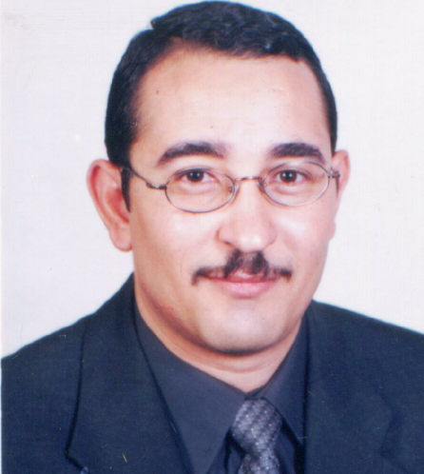
CURRICULUM VITAE
Personal Data:
Family Name: Hashem
First Name: Essam El-Deen Abd-Elmohsen Mohammed.
Date of Birth: November 22, 1971
Citizenship: Egyptian
Marital State: Married
Current Post: Assistant Professor, Gastroenterology and Hepatology Unit,
Address: Internal Medicine Department,
Assiut University Hospitals,
Assiut 71516,
Egypt
Telephone: (+20) 88-2367170
Cellular: (+20) 101971906
Phone Work: (+20) 88-413940
Fax: (+20) 88-2333327
Email: essam_223@yahoo.com

Qualifications and Degrees:
Degree | Institution | Date
Medical School Diploma (MBBCH, Bachelor of Medicine and Bachelor of Surgery), Very good | Faculty of Medicine Assiut University | September 1995
M. Sc. (Master Degree Internal Medicine) | Internal medicine Department, Faculty of Medicine, Assiut University  Thesis: Prospective study of Histoacryl injection of fundal varices and portal hypertensive gastropathy. | April 2000
M.D. Medical Doctorate in Internal Medicine | Internal medicine Department, Faculty of Medicine, Assiut University  Thesis: Comparative prospective study of combined ligation sclerotherapy versus ligation alone versus sclerotherapy alone of various grades of variceal bleeding in Upper Egypt. | June 2007

Positions Held:
Position | Institution | Date (period)
Resident Doctor | Internal medicine Department, Faculty of Medicine, Assiut University | March 1996 - April 2000
Assistant Lecturer | Internal medicine Department, Faculty of Medicine, Assiut University | April 2000 - June 2007
Lecturer, Internal Medicine Department | Gastroenterology and Hepatology Unit, Internal medicine Department, Faculty of Medicine, Assiut University | June 2007
Assistant Professor | Gastroenterology and Hepatology Unit, Internal medicine Department,  Faculty of Medicine, Assiut University | January 2013

Past Research Interest
1-The effect of Histoacryl on controlling bleeding fundal varices and the relation to the development of portal hypertensive gatropathy.

2- Changes of portal hemodynamics detected by Doppler Ultrasonography after Histoacryl injection of fundal varices.

3- The difference in the effect of band ligation, Histoacryl injection and ethanolamine on haemostasis of bleeding esophageal varices and it's relation to portal vein haemodynamic.

Clinical Experience
- Early diagnosis and prompt treatment of internal medicine emergencies.
- Good experience in coronary and intensive care unit
- Diagnosis and management of different internal medicine diseases including Gastroenterology, Cardiology, Rheumatology, Hematology, Nephrology and Endocrinology.
- Subspecialty In: Gastroenterology and Hepatology
- Esophago-gastro-duodenoscopy (EGD)
- Esophageal sclerotherapy and band ligation
- Esophageal 24 hour pH monitoring
- Motility study.
- Abdominal US.
- Doppler on portal vein.
- Liver biopsy.
- Histoacryl injection of fundal varices.
- Laser photocoagulation of bleeding gastroduodenal ulcers.
- Diagnostic colonoscopy.
- Therapeutic colonoscopy in the form of polypectomy and laser photocoagulation of angiomatous malformations, ulcerations and band ligation of anorectal varices.

Teaching and Educational Activities
Teaching at Assiut University, Internal Medicine Department.
- Undergraduate Lectures and clinical rounds for Medical students
- Post graduate Lectures.
- Annual meeting of the Faculty of Medicine, Assuit University
- Weekly department conference activity.

Language courses
- Institutional Toefl Testing Program (ITP), June, 2001.
- Level 3 of English Language ,English Language Centre Programme, Assiut University on June, 2006.
Computer Skills
- Very Good experience in Microsoft Word, PowerPoint, Excel, Acrobat PDF & Internet.
- Good experience in Access and Word Perfect.
- Very Good experience in SPSS software (biostatistics program).

Attended Courses
- Teaching for Learning, Faculty and Leadership Development Project (FLDP), Assiut University, Egypt, October, 2004.
- Active Communication Skills, Faculty and Leadership Development Project (FLDP), Assiut University, Egypt, October, 2005.
- Teaching with Technology, Faculty and Leadership Development Project (FLDP), Assiut University, Egypt, July, 2006.
- Ethics and Manners of teaching, Faculty and Leadership Development Project (FLDP), Assiut University, Egypt, July, 2006.

Attended Scientific Courses

- Course on Chronic Hepatitis, The Third Egyptian Digestive Disease Week, The Egyptian Society of Endoscopy and Hepato-gastroenterology "ESEHG" in collaboration with ESGE/ OMGE/ OMED, on March 29, 2005.

- Course on Portal Hypertension ,The Third Egyptian Digestive Disease Week, The Egyptian Society of Endoscopy and Hepato-gastroenterology "ESEHG" in collaboration with ESGE/ OMGE/ OMED, on March 30, 2005.

- Course on Ultrasonography for Hepato-gastroenterologists ,The Third Egyptian Digestive Disease Week, The Egyptian Society of Endoscopy and Hepato-gastroenterology "ESEHG" in collaboration with ESGE/ OMGE/ OMED, on March 31, 2005.

ATTENDED MEETINGS
- The First Annual Congress of Internal Medicine "Modern Trends in Nephrology", Faculty of Medicine- Assiut University on April 8-9, 2003.

- The Second Annual Congress of Internal Medicine "Controversial Aspects in Gastrointestinal and Liver Diseases", Faculty of Medicine- Assiut University on February 17-18, 2004.

- Precongress Workshops and Scientific Program of the 4th Meeting of Italo-Egyptian Association for Digestive Diseases and 7th International Workshop of Therapeutic Endoscopy and Laparoscopy, on March 23rd-25th, 2004.

- XXIInd European Workshop on Gastroenterology and Endotherapy, Brussels Exhibition Centre- Belgium on June 21-23, 2004.

- 23rd Annual Conference of Faculty of Medicine- Assiut University on March 7-10, 2005.

- The Third Egyptian Digestive Disease Week, The Egyptian Society of Endoscopy and Hepato-gastroenterology "ESEHG" in collaboration with ESGE/ OMGE/ OMED, on March 27-31, 2005.

- Continuing Education & Training, Med Reg Jab Course, Birkbeck University, London, England on July 18-21, 2006.

